# Date: 2025/08/08 Title: Introduction to Packet Tracer

# THEORY:

**a) Background Information**

Cisco Packet Tracer is a network simulation developed by Cisco Systems. It allows users to simulate complex networks by configuring various network devices and testing different scenarios in a virtual environment. The software is particularly useful for education purposes, providing a platform for students to experiment with network designs and configurations without the need for physical hardware.

**b) Key Concepts of Cisco Packet Tracer**

Packet Tracer offers a range of features that support network design, configuration, and simulation. Some key concepts include:

**Network Simulation:** The ability to simulate real-world network scenarios with a wide range of devices and protocols.

**Real-Time and Simulation Modes:** These modes allow users to view the network’s behavior in real-time or to simulate the propagation of packets step by step.

**Activity Wizard:** A feature that enables the creation of guided learning activities within the software.

**Interface of Cisco Packet Tracer**

The interface of Cisco Packet Tracer is designed to be user-friendly, with various panels and tools to facilitate network design and simulation.

**a) Work Space Details**

The workspace is the primary area where you design and visualize your network topology. You can drag and drop devices such as routers, switches, and end devices onto the workspace and connect them using different types of cables. The workspace is equipped with grid lines for precise alignment and organization of components, allowing for a clear and structured network diagram.

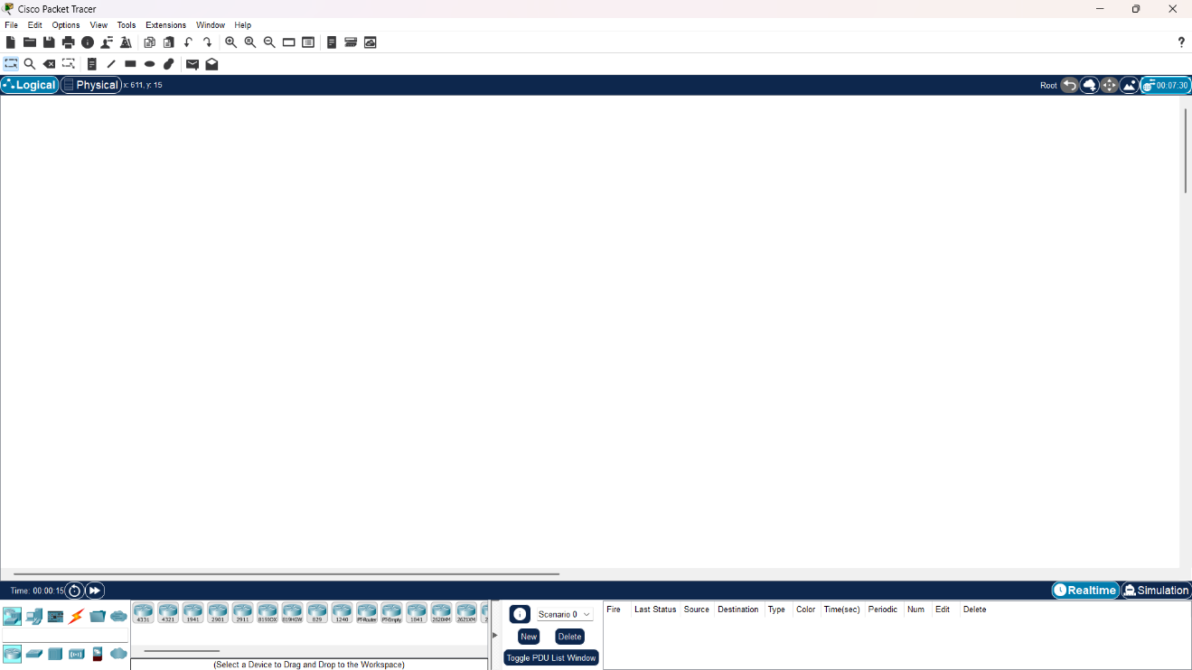

Fig: Cisco Packet Tracer Workspace

**b) Toolbar**

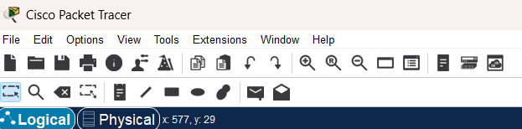The toolbar provides quick access to essential functions like saving and opening files, zooming in and out, and controlling the simulation process. It also allows you to switch between views, such as physical and logical views, of your network. The toolbar streamlines your workflow by offering direct access to frequently used tools and settings.

Fig: Toolbar in Cisco packet tracer

**c) Device-Type Selection Panel**

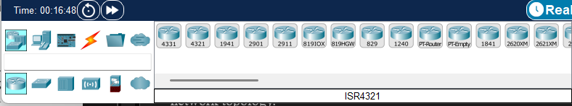This panel, located on the left side of the interface, lists all available network devices organized by category, such as routers, switches, and end devices. You can easily select a device from this panel and drag it onto the workspace to include it in your network design. This panel simplifies the process of finding and placing the necessary devices for your network topology.

fig: Device selection panel

**d) Device Configurations**

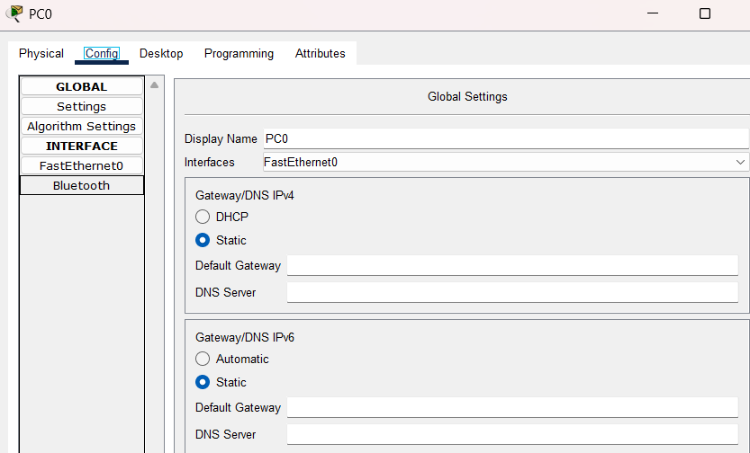After placing a device on the workspace, you can configure its settings through a configuration window. This includes assigning IP addresses, setting up routing protocols, and enabling specific features like DHCP or NAT. The configuration can be done using both a graphical interface and a command-line interface (CLI), providing flexibility for both beginners and advanced users.

Fig: Device configuration settings

**e) Real-Time and Simulation Mode**

Packet Tracer operates in two modes: Real-Time Mode, where network actions occur instantly as they would in a real network, and Simulation Mode, which allows you to pause and step through the network’s operations. Simulation Mode is particularly useful for analyzing packet flow, understanding protocol behavior, and troubleshooting network issues by observing data movement across the network.

Fig: Different modes in Cisco packet tracer

**f) Network Component Icons and Labels**

Devices and connections in the workspace are represented by specific icons, making it easy to identify different network components. Labels can be added to these icons to provide additional details, such as device names, IP addresses, or VLAN information. These labels help organize the network diagram and improve clarity, making it easier to understand and manage complex network designs.

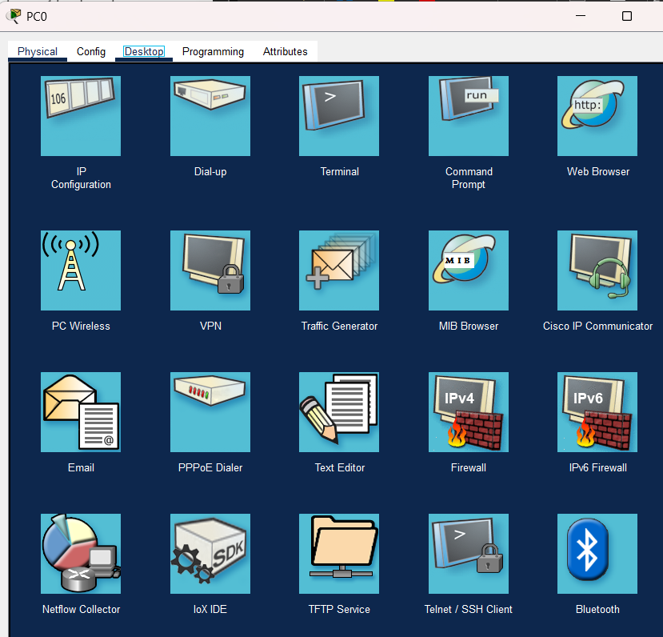

Fig: Network component icons and labels

**e) Options and Preferences**

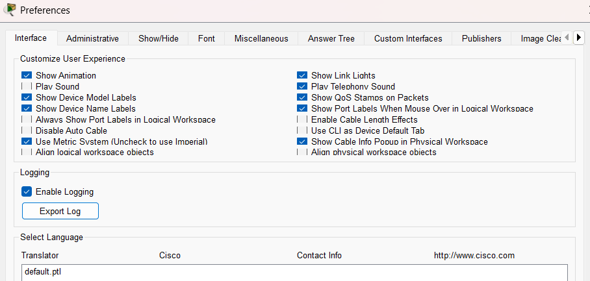The Options and Preferences menu allows you to customize your Packet Tracer environment. You can adjust visual settings like background color and font size, set default values for device configurations, and manage simulation speeds. This customization helps tailor the software to your personal preferences and working style, enhancing your overall experience.

Fig: Option and preferences menu

**f) Activity Wizard**

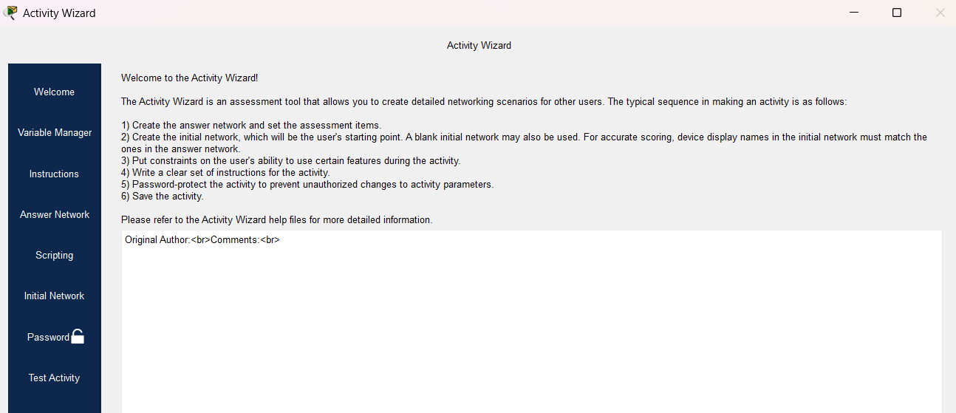The Activity Wizard is a feature designed for creating interactive learning activities within Packet Tracer. Instructors can use it to design tasks, provide step-by-step instructions, and set up assessments that students can follow within the software. This tool is particularly useful for educational purposes, allowing students to practice and test their networking skills in a guided and structured environment.

Fig: Activity wizard feature

**Conclusion:**

Cisco Packet Tracer is an essential tool for students studying computer networks, providing a safe and flexible environment to learn and experiment with various network configurations. Understanding its interface and functionalities is crucial for effectively using the software to design and simulate network topologies. The lab provided a practical understanding of networking concepts like routing, switching, and addressing, which are fundamental to computer networking.